2014-2017 International Collaboration
2017
- 2017.06.26 Dr Shih-fen Hsiao will represent the TPTA for the MOU exchange ceremony for JPTA and TPTA. The ceremony is organised by JPTA for Asian Confederation for Physical Therapy (ACPT) countries.
2015
- 2015.09.01-10.30 Two undergraduate students (Ms. Shin-Yi Lin and Ms. Hui-Ci Zhang) of Department of Medical Imaging and Radiological Sciences completed clinical rotation in Singapore General Hospital.
- 2015.05.04 Director Wu signed MOU with Department of Health Technology and Informatics, The Hong Kong Polytechnic University
(Host: Department of Medical Laboratory Science and Biotechnology)
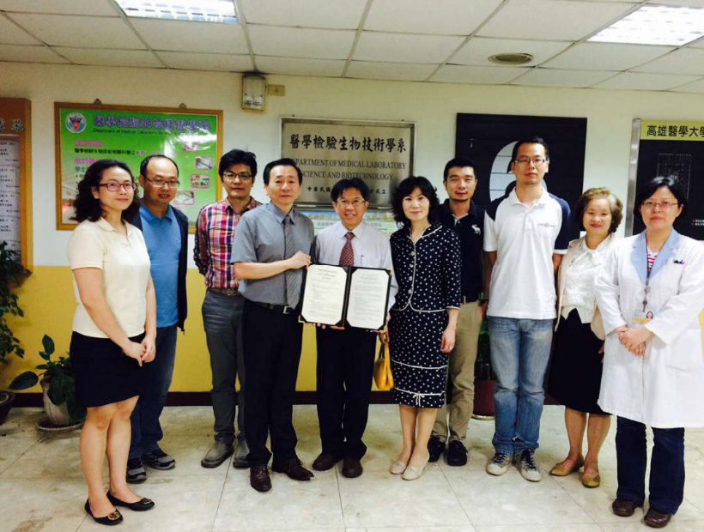
- 2015.01 Signed MOU with Universidad Miguel Hernández, Spain.
(Host: Department of Physical Therapy)
2014
- 2014.11.15‐19 Professor Chien-Hung Lee joined the Kaohsiung Medical University delegation. The delegation went to Tulane University School of Public Health and signed a memorandum of teaching and research in collaboration with them.
(Host: Department of Public Health)
- 2014.11.14-19Professor Hon-Yi Shi attended (1) Signing Ceremony of memorandum of understanding (MOU) between Tulane University and Kaohsiung Medical University (2) participate in the American Public Health Association (APHA)
(Host: Department of Healthcare Administration and Medical Informatics)

